National Arbitration Forum

DECISION

Blind Melon v. Mark
Claim Number: FA0606000741833

PARTIES
Complainant is Blind Melon (“Complainant”), represented by David Rudich, of Law Offices of David Rudich, 9255 Sunset Boulevard, Suite 920, Los Angeles, CA 90069. Respondent is Mark (“Respondent”), represented by Barbara L. Friedman, of Hanson, Bridgett, Marcus, Vlahos & Rudy, 425 Market Street, 26th Floor, San Francisco, CA 94105.

REGISTRAR AND DISPUTED DOMAIN NAME
The domain name at issue is <blindmelon.com>, registered with Intercosmos Media Group, Inc. d/b/a Directnic.Com.

PANEL
The undersigned certifies that he or she has acted independently and impartially and to the best of his or her knowledge has no known conflict in serving as Panelist in this proceeding.

David S. Safran, as Panelist.

PROCEDURAL HISTORY
Complainant submitted a Complaint to the National Arbitration Forum electronically on June 29, 2006; the National Arbitration Forum received a hard copy of the Complaint on July 3, 2006.

On June 30, 2006, Intercosmos Media Group, Inc. d/b/a Directnic.Com confirmed by e-mail to the National Arbitration Forum that the <blindmelon.com> domain name is registered with Intercosmos Media Group, Inc. d/b/a Directnic.Com and that the Respondent is the current registrant of the name. Intercosmos Media Group, Inc. d/b/a Directnic.Com has verified that Respondent is bound by the Intercosmos Media Group, Inc. d/b/a Directnic.Com registration agreement and has thereby agreed to resolve domain-name disputes brought by third parties in accordance with ICANN’s Uniform Domain Name Dispute Resolution Policy (the “Policy”).

On July 7, 2006, a Notification of Complaint and Commencement of Administrative Proceeding (the “Commencement Notification”), setting a deadline of July 27, 2006 by which Respondent could file a Response to the Complaint, was transmitted to Respondent via e-mail, post and fax, to all entities and persons listed on Respondent’s registration as technical, administrative and billing contacts, and to postmaster@blindmelon.com by e-mail.

A Response was received late in hard copy on July 31, 2006 and therefore the National Arbitration Forum has determined the Response to be deficient according to Supplemental Rule 5(a).

On August 7, 2006, pursuant to Complainant’s request to have the dispute decided by a single-member Panel, the National Arbitration Forum appointed David S. Safran as Panelist.

RELIEF SOUGHT
Complainant requests that the domain name be transferred from Respondent to Complainant.

PARTIES’ CONTENTIONS
A. Complainant

Complainant contends that even though the name BLIND MELON is unregistered, it has become famous and associated with Complainant as a musical recording group and thus has common law rights in the BLIND MELON name. Complainant further contends that Respondent is merely profiting from Complainant’s name and thus has no rights or legitimate interests in the disputed domain name and is using it in bad faith. Furthermore, Complainant contends that Respondent has attempted to resell the disputed domain name to Complainant.

B. Respondent

Respondent contends that Complainant has failed to establish that the domain <blindmelon.com> was registered in bad faith. Respondent further contends that it was Complainant that initiated discussions with respect to sale of the domain name and that these proceedings are solely the result of Complainant’s inability to acquire the domain name by purchase.

FINDINGS
Complainant has failed to provide any evidence which would indicate that the domain name was acquired in bad faith and Respondent has indicated that it was acquired legitimately from the prior owner of the domain name <blindmelon.com>. Furthermore, Respondent has provided evidence that at least one member of the band new of the website using the <blindmelon.com> domain name, and the band has made use of and benefited from activities at the <blindmelon.com> website for several years. Additionally, it is common public knowledge that the band Blind Melon ceased to exist around 1995 after the death of one of its band members and that surviving band members have and are performing in differently named bands.

DISCUSSION
Paragraph 15(a) of the Rules for Uniform Domain Name Dispute Resolution Policy (the “Rules”) instructs this Panel to “decide a complaint on the basis of the statements and documents submitted in accordance with the Policy, these Rules and any rules and principles of law that it deems applicable.”

Paragraph 4(a) of the Policy requires that the Complainant must prove each of the following three elements to obtain an order that a domain name should be cancelled or transferred:

- the domain name registered by the Respondent is identical or confusingly similar to a trademark or service mark in which the Complainant has rights;
- the Respondent has no rights or legitimate interests in respect of the domain name; and
- the domain name has been registered and is being used in bad faith.

Identical and/or Confusingly Similar

Since the panel finds that Complainant has not established that the Respondent has no rights or legitimate interests in respect of the domain name; and that the domain name has been registered and is being used in bad faith, the panel finds it unnecessary to determine whether Complainant has rights in a trademark or service mark relative to which the domain name is identical or confusingly similar.

Rights or Legitimate Interests

Respondent contends that it has been using the <blindmelon.com> domain name since 2000 to operate a fan website devoted to Complainant’s music. Respondent claims that the website became extremely popular after its registration and that fans of Complainant posted over 20,000 messages at the website’s message board between 2001 and 2005. Respondent has provided evidence that at least one member of Complainant has made use of the Respondent’s website to post messages and provided Respondent CDs of its latest releases to post on the website and agreed to let Respondent interview Complainant for the website. As a result, Respondent maintains, it is using the <blindmelon.com> domain name for a legitimate noncommercial or fair use under Policy ¶ 4(c)(iii). The Panel finds that Respondent has rights or legitimate interests in the <blindmelon.com> domain name because the operation of a fan website is a legitimate noncommercial or fair use according to Policy ¶ 4(c)(iii). See 2001 White Castle Way, Inc. v. Jacobs, D2004-0001 (WIPO Mar. 26, 2004) (holding that the respondent had rights or legitimate interests in the <patbenatar.com> domain name where the respondent was operating a fan website with information on the complainant, a recording artist); see also Pearl Jam, A Gen. P’ship v. Streaming Digital Media Dot Com, FA 235831 (Nat. Arb. Forum Mar. 29, 2004) (“The Panel is of the view that Respondent’s evidence and Complainant’s admissions support the conclusion that Respondent’s noncommercial use of the Domain Name in association with Respondent’s fan site is ‘legitimate.’”). The Panel also finds that such use of the domain name in association with Respondent’s fan website was with the knowledge and at least tacit consent of Complainant which made use of the website for Complainant’s benefit.

Registration and Use in Bad Faith

Respondent alleges that it registered the <blindmelon.com> domain name in good faith in order to maintain a fan website devoted to Complainant’s music. The Panel holds that Respondent’s operation of a fan website at the <blindmelon.com> domain name does not provide evidence of bad faith registration and use under Policy ¶ 4(a)(iii). See Van Halen v. Morgan, D2000-1313 (WIPO Dec. 20, 2000) (finding that the respondent did not register the <edwardvanhalen.com> domain name in bad faith where she had a desire to use the domain name for a fan site devoted to the complainant); see also Stuart. v. Marty Stuart Fan Page, FA 192600 (Nat. Arb. Forum Oct. 22, 2003) (finding that the respondent’s registration and use of a domain name to host a fan website was not bad faith because the domain name was registered in support of the complainant). The Panel finds the Stuart. v. Marty Stuart Fan Page case particularly relevant in view of the evidence that Complainant made repeated use of the website to further Complainant’s interests and in effect encouraged Respondent’s activities. Moreover, the Panel finds that having made use of the activities at Respondent’s website for Complainant’s own benefit, it is inconsistent for Complainant to then assert that such activities were adverse to its interests and in bad faith.

DECISION
Complainant having failed to establish two of the three elements required under the ICANN Policy, the Panel concludes that relief shall be DENIED.

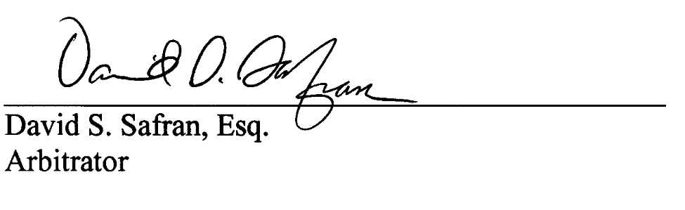

David S. Safran Panelist
Dated: August 21, 2006

Click Here to return to the main Domain Decisions Page.

Click Here to return to our Home Page

